Module 1: Civic Pride
Exercise 3: What is Civic Pride?
Source: https://grammartop.com/civic-synonyms/

Please watch the following video:
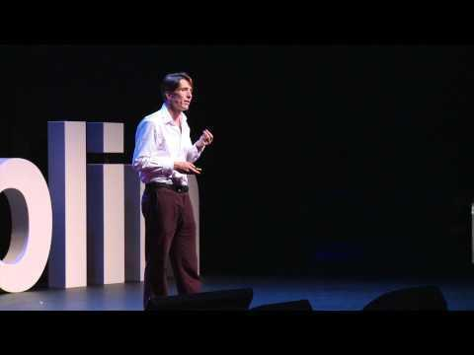
(Source: https://www.youtube.com/watch?v=sLJVsGcPSMI)

Now answer the following questions:
Did you find the video interesting?
(1: not at all, 2: little interest, 3: neutral, 4: interesting, 5: very interesting)

Did you find a common ground between the video presentation with your cities/communities and the experience you have as a citizen/member of a community?
(1: not at all, 2: little interest, 3: neutral, 4: interesting, 5: very interesting)

Did you understand the importance of Civic Pride in your personal life and your community’s life?
(1: not at all, 2: little interest, 3: neutral, 4: interesting, 5: very interesting)

[If participants watch this video in a seminar room they could have a group discussion on these questions facilitated by the c.p]
If you created a similar video presenting civic pride in your city or local community which things would you mention for your city or local community. Make a short list of 10 things you would like to point out in your presentation.

