Module 4: Hardware and Software Divisions of the Cities
Exercise 1: The physical divisions our city
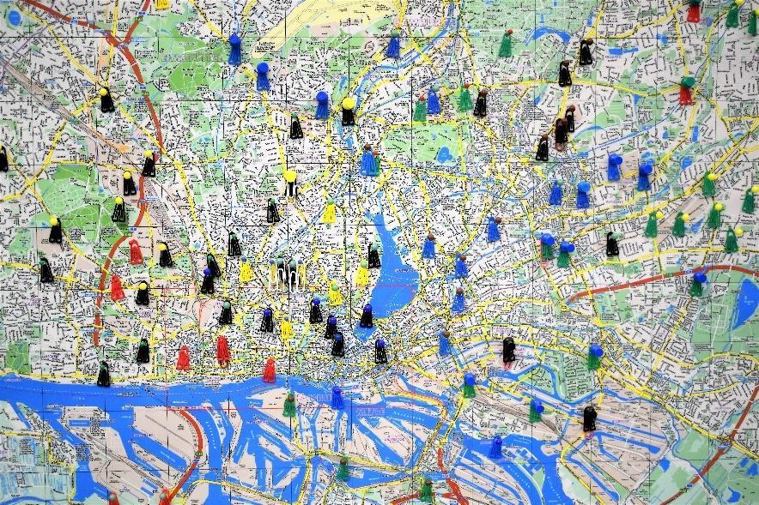
Source: https://unsplash.com/photos/aHZF4sz0YNw by Waldemar Brandt
Steps:
- Use GmapGIS: https://www.gmapgis.com/ or Scribblemaps: https://www.scribblemaps.com/ to find the map of your own city/town and draw on the map using the Draw Tool [Draw a line or a circle] spotting the physical divisions that may exist in your city e.g. a lake, a river, a large hill/mountainside, the seaside, the walls of an ancient monument etc. You can draw a line of the division that a physical landmark creates in your city and use the “Label” tool to write down what kind of a division is that.
- Think about: Are these physical divisions also related with cultural/religious divisions or socioeconomic divisions regarding the areas in your city?
- If yes, please write down each relevant choice and provide also a small comment about the area you chose. [e.g, The Jewish neighbourhood is traditionally close to this hill for historical reasons, or e.g., you can spot more underdeveloped neighbourhoods on that side of the river etc.]

Area | Type of related Divisions | Comment
 | Socioeconomic division
 | Cultural/Religious division

- Briefly present your answers and discuss in the seminar room, with your fellow participants your map and your answers. (Optional)

Some food for thought:
- Did you find the exercise interesting?
- How many physical divisions exist in your city?
- Is there a connection between physical divisions and socioeconomic characteristics of these parts of the city?
- Were your maps and answers similar to your fellow participants, did you find common ground in your discussion?

