Module 1: Civic Pride
Exercise 6. Community Garden
Community gardens can be powerful contributors to healthy communities by:
- Increasing access to healthy foods and educate people about food and nutrition;
- Supporting social cohesion and build a sense of community;
- Promoting safer neighbourhoods.

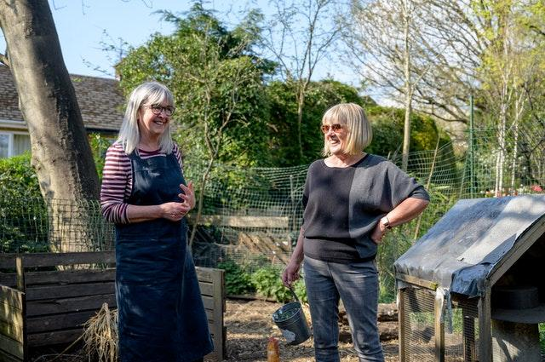
Source: https://www.pexels.com/photo/woman-in-black-long-sleeve-shirt-standing-beside-woman-in-black-and-white-striped-long-sleeve-7849905/ by Centre for Ageing Better

On this website, you can find a 10 steps process to create a successful Community Garden for Residents.

Here are some Youtube videos links on the topic:
- https://www.youtube.com/watch?v=5xe03SHh8SE
- https://www.youtube.com/watch?v=2U8GxT0uVkM
- https://www.youtube.com/watch?v=xm0zriG9UrY (French)

- Did you find this type of initiative interesting?
- Do you understand the importance of building a sense of community and social cohesion through this type of initiative?
- Is it feasible in your area?

