Module 1: Civic Pride
Exercise 1b. Why is our city’s unique identity important to us?

According to the city you are living in, check out the following links with videos of your city:
Ajaccio (FR) | 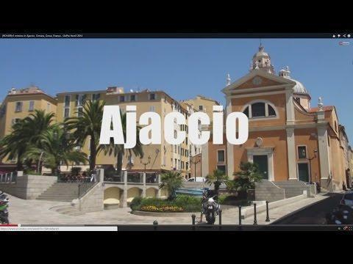  https://www.youtube.com/watch?v=KTnBAdSMAR4
Athens (GR) | 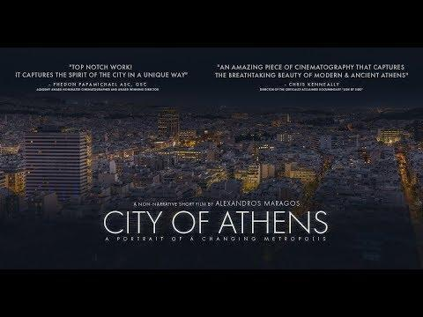  https://www.youtube.com/watch?v=9Dm57Ed-2KU
Burmingham (UK) | 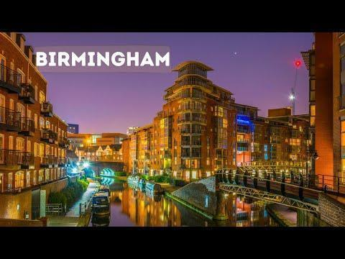  https://www.youtube.com/watch?v=6dSK8UEYn-s
Finsterwalde (DE) | 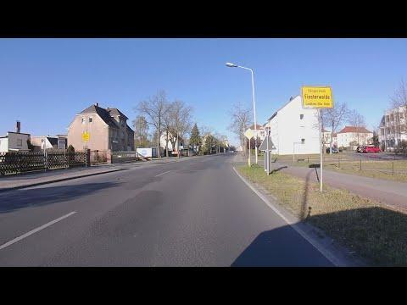  https://www.youtube.com/watch?v=TTAgjhTZJ3k
Portalegre (PR) | 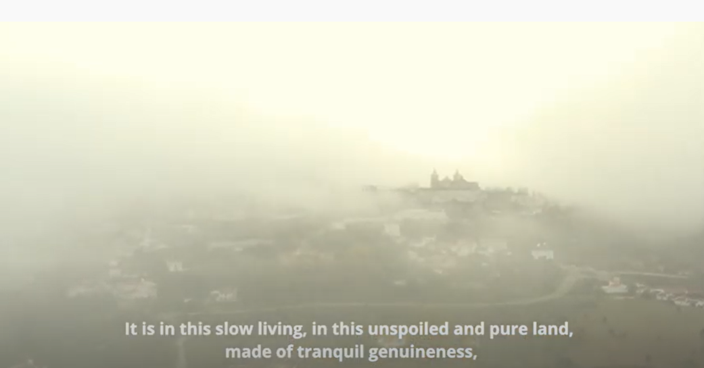  https://www.youtube.com/watch?v=nGvfvZKjJ40
Stockholm (SE) | 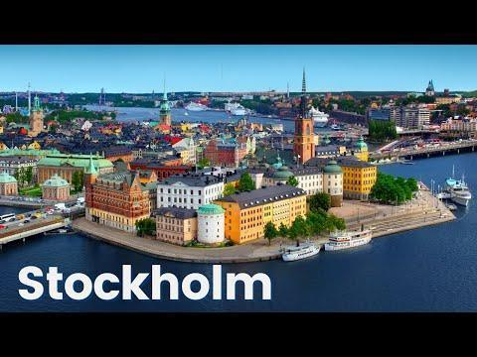  https://www.youtube.com/watch?v=3gCSRrkZG1U

Please choose and write down 5 places from your city that are the most characteristic of your city in your opinion.
1.
2.
3.
4.
5.

Please choose and write down 3 traditions or cultural elements from your city that are the most characteristic of your city and are important for you and your community. (e.g. festivals, traditional arts, traditions/customs)
1.
2.
3.

Please answer the following questions based on your choices:
- How important are the traditions or cultural elements you chose in your upbringing and your personal experience?
(1: not at all, 2: little importance, 3: neutral, 4: important, 5: very important)

- Do you feel that the traditions or cultural elements you have chosen create a bond between you and the people you grew up with (family, friends, neighbours, members of community)?
(1: did not agree at all, 2: disagree, 3: neither agree nor disagree, 4: agree, 5: totally agree)

Now Check out the choices from other fellow citizens and compare, do you find some choices you have in common?
- Traditions/Cultural elements Chosen
(1: did not agree at all, 2: disagree, 3: neither agree nor disagree, 4: agree, 5: totally agree)

Now Check out the choices from other fellow citizens, do you find some choices you have in common? Do you share similar opinions? please vote from 1-5 how much you agree with your citizens.
- Importance of traditions/cultural elements chosen in upbringing and personal experience
(1: did not agree at all, 2: disagree, 3: neither agree nor disagree, 4: agree, 5: totally agree)

- Feeling of bond between you and the people you grew up with (family, friends, neighbours, members of community)?
(1: did not agree at all, 2: disagree, 3: neither agree nor disagree, 4: agree, 5: totally agree)

“Belonging in a community/city is about sharing common memories, emotions, beliefs with other people. It’s about being members of a larger group, be it community, a neighbourhood, or a city, that share similar or common experiences, cherish common things, share common backgrounds. Civic Pride is about active engagement in various types of social and civic activities, promoting the development and the wellbeing of a community and its members”.

