Module 1: Civic Pride

Exercise 1a. What makes our city unique?

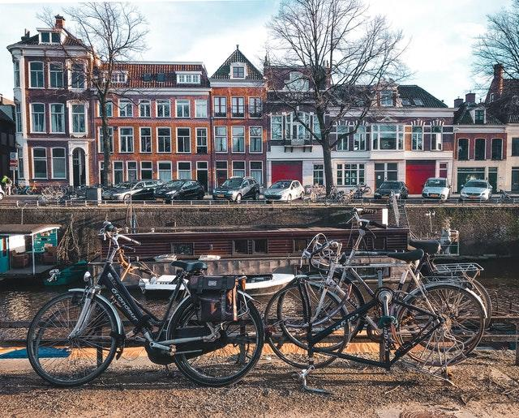
Source: https://www.pexels.com/photo/bicycles-parked-beside-brown-wooden-fence-near-a-river-3424845/ by Kayla Ihrig

According to the city you are living in, check out the following links with pictures of your city from Istock.com, adobestock.com or other sites:
- Ajaccio:https://bit.ly/3m6rtjH
- Athens:https://bit.ly/3ihTeEP
- Birmingham:https://bit.ly/3ohK6nn
- Finsterwalde:https://adobe.ly/3ihESo5
- Portalegre:https://adobe.ly/3zVmh70
- Stockholm: https://adobe.ly/2Y9WivR
Please choose 5 of them that are the most characteristic of your city in your opinion.
1.
2.
3.
4.
5.

Now write down 2 sentences for each picture you chose. explaining:
- Why in your opinion are they important for your city’s identity and for you?
1.
2.

- What kind of memories do they bring you?
1.
2.

- Is there an important element that defines your city that you did not see in the pictures? Please mention it in a comment.

Now check out the choices from other fellow citizens and compare. Do you find some choices you have in common? Please vote from 1-5 how much you agree with your citizens.
- Places Chosen
(1: did not agree at all, 2: disagree, 3: neither agree nor disagree, 4: agree, 5: totally agree)

- Why are these places important for your city’s identity and for you?
(1: did not agree at all, 2: disagree, 3: neither agree nor disagree, 4: agree, 5: totally agree)

Now check out some of their comments regarding their memories and emotions and make a short comparison. Do you have similar memories or/and emotions? Please vote from 1-4 how much you identify with their choices.
(1: not at all, 2: partly, 3: in most cases, 4: very much)

Self-reflective question: Think about the similarities you had in your answers with your fellow citizens. Why do you think you may have similar choices and share common emotions or beliefs?
“Belonging in a community/city is about sharing common memories, emotions, beliefs with other people. It’s about being members of a larger group, be it community, a neighbourhood, or a city, that share similar or common experiences, cherish common things, share common backgrounds. Civic Pride is about active engagement in various types of social and civic activities, promoting the development and the wellbeing of a community and its members”.

